Centroids – Guided Notes

Centroid Basics
The centroid is an object’s ______________________________ or ______________________________.
It is the point where force due to gravity acts, also called the point of ______________________________.
An object is in ______________________________ when it is balanced at its centroid.
Why is centroid important in statics?
____________________________________________________________
____________________________________________________________

Determining Centroid Location
The centroid can be found using a ______________________________ view of a 3D object.

Symmetrical Objects
The centroid lies on the object’s ______________________________.
If there are multiple lines of symmetry, the centroid is at the ______________________________.
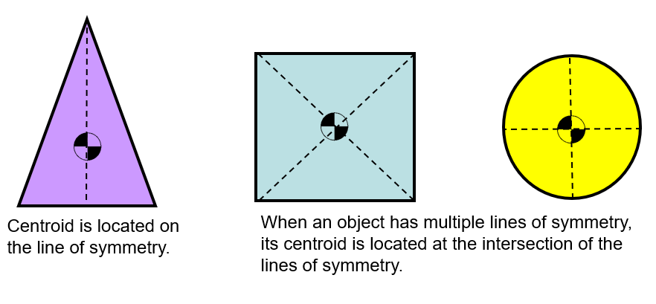

Common Shapes & Centroids
Rectangle/Square:
x = __________ y = __________
Right Triangle:
x = __________ y = __________
Semi-Circle:
Distance from axis = __________

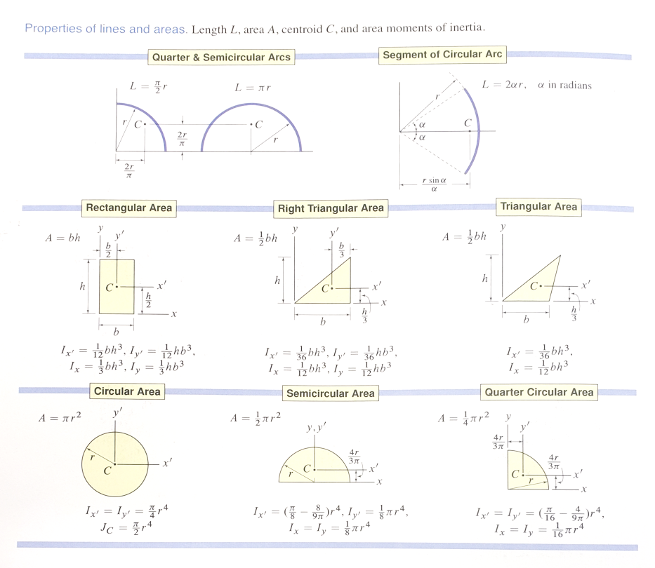

Complex Shapes
Formulas:
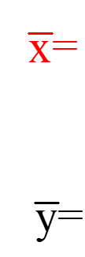

Practice Problem
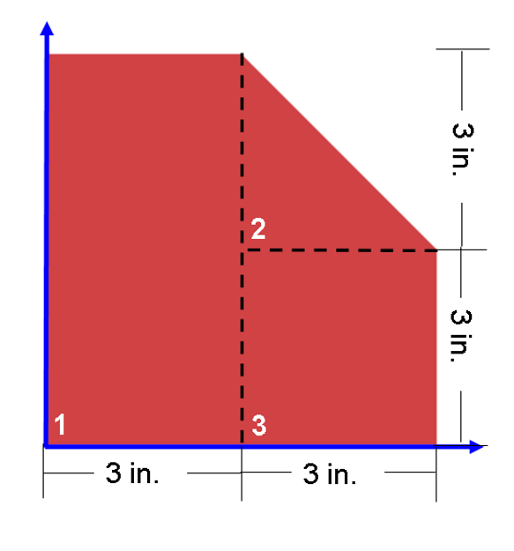

Subtractive Method

Structural Shapes
Examples:
- L-Shape
- C-Shape
- Box Shape
- I-Beam
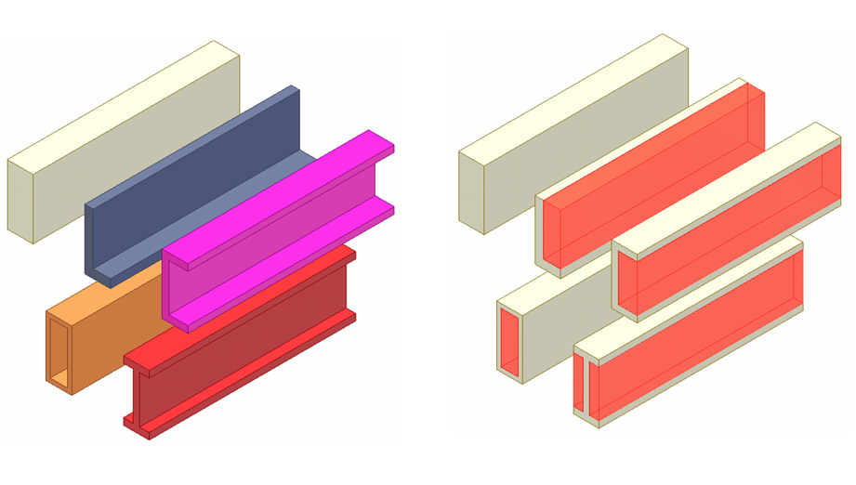

Moment of Inertia
Defined as:
____________________________________________________________
____________________________________________________________
Practice (2x4):
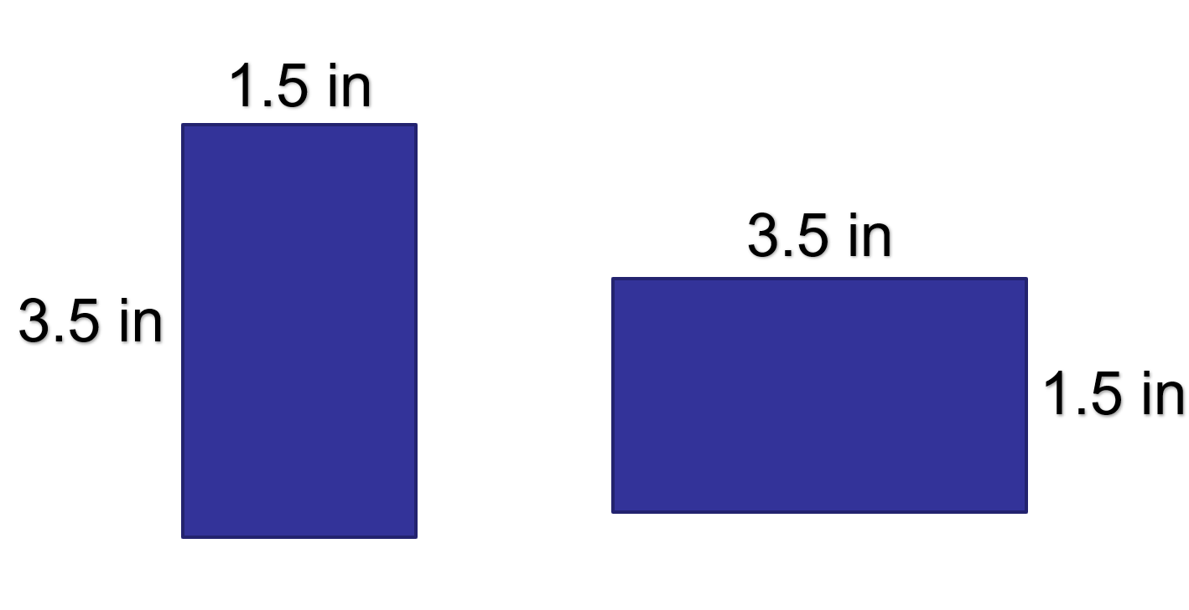

Parallel Axis Theorem

